Lens

Realtime audio transcriber for audio-deficiency people in AR

Team members: Butnaru Vlad Andrei, Aprofirei Cezara Teofana, Mariniuc Eduard Stefan

Description

1. One paragraph about **why** this app

Our app is an addition to the A11Y ideas which allows people with hearing deficiency to participate in live activities where a speaker is trying to transmit information that usually is not present on written materials.

1. One paragraph about **how** this app will achieve the why

The app will be based on an AR-headset that will augment near the talking person a transcribe of the speech. The user will be able to read the text and understand the entire ideas presented.

1. **What is different** compared to other solutions. We will allow translations into Romanian, Deutsch, Spanish and customization of the ui.

Similar products & Relevant Links(>=3)

**Name: Transcribe Glass**

**Url https://www.youtube.com/watch?v=9DnMcI3Vdbk**

**Relevant Features**

- Is an attachment to the glasses

- Relying on external APIs

- Latency relatively small

**Name aws translation**

**UrlȘ aws….**

**Relevant Features**

* Low latency translations and speech to text

Main Features

* **PRINCIPAL MAIN VERY IMPORTANT FEATURE: Subtitles from the speaker**
* **Other features**
* **Translation**
* **Customization of the subtitles**

User Journey Diagram - Step by step flow through app

Moodboard (10+ images)

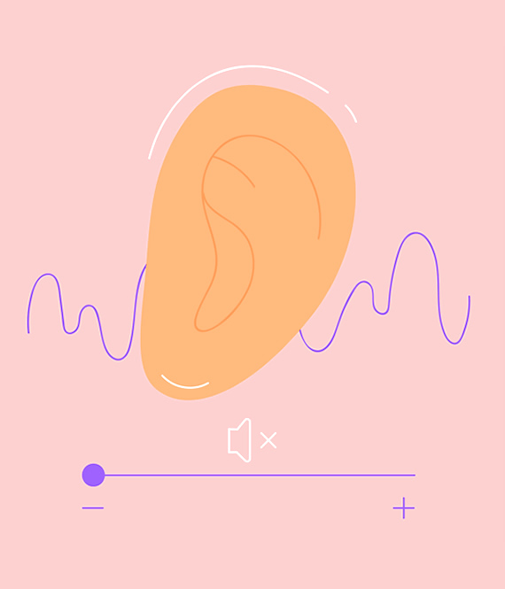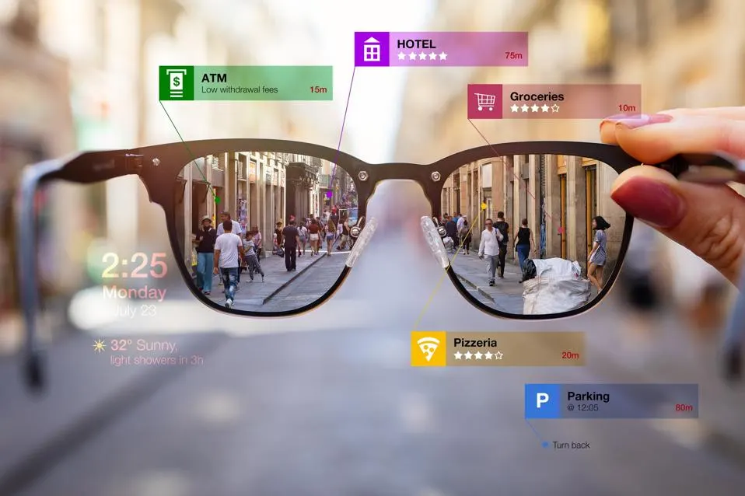

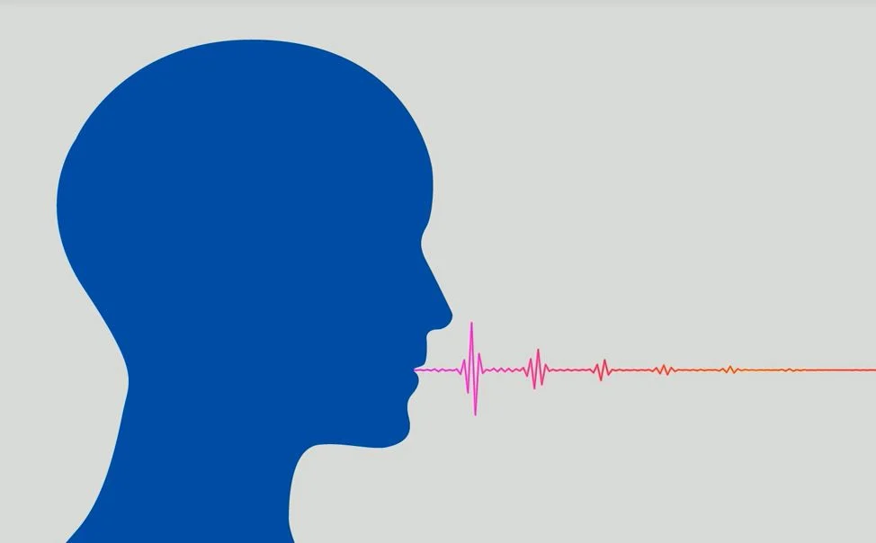

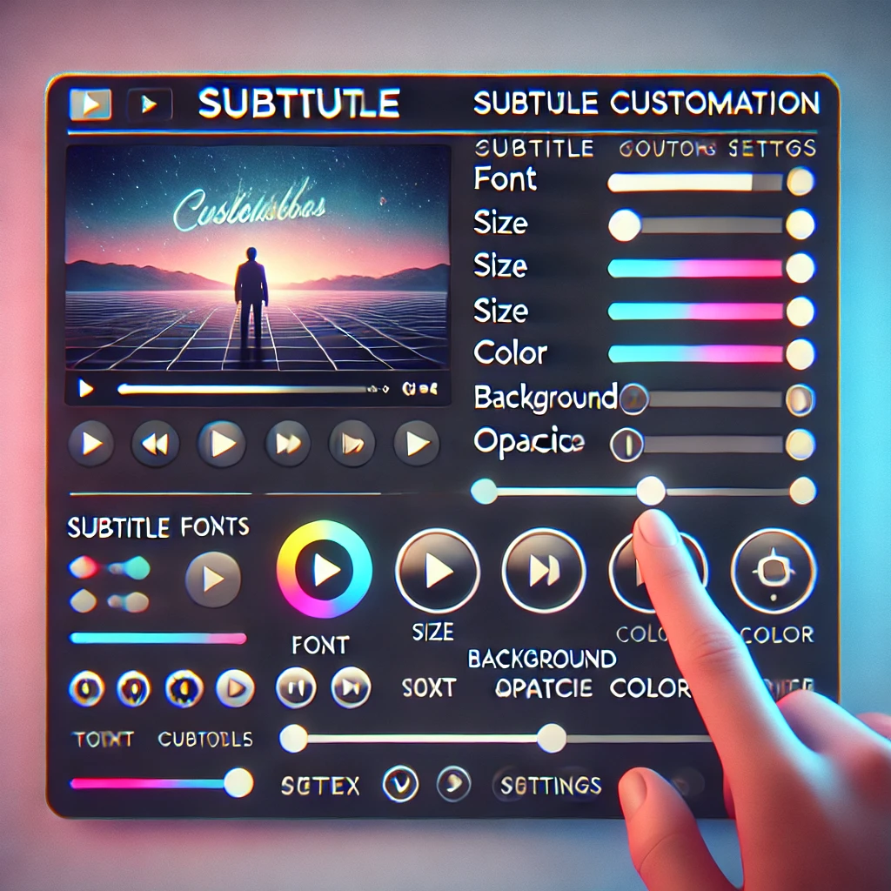[

------------------------------------------------------------------------------------->>

Technologies, Libraries, Assets - Links (>=5)

1. - gpt whisper model
2. - vuforia
3. - node js in servers
4. - libraries for ui cosmization
5. - claude for translations
6. -
7. -